1. **Repository Setup and Initial Commit**

Steps:

1. Create a new repository on GitHub
   1. Go to [GitHub](https://github.com) and create a new repository (e.g., project-repo).
   2. Do not initialize it with a README (we will do that locally).
2. Clone the repository locally

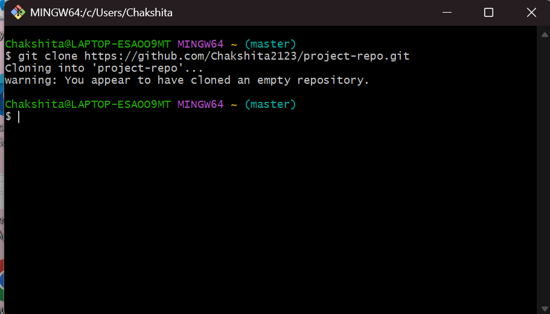

1. Initialize Git and create the first commit

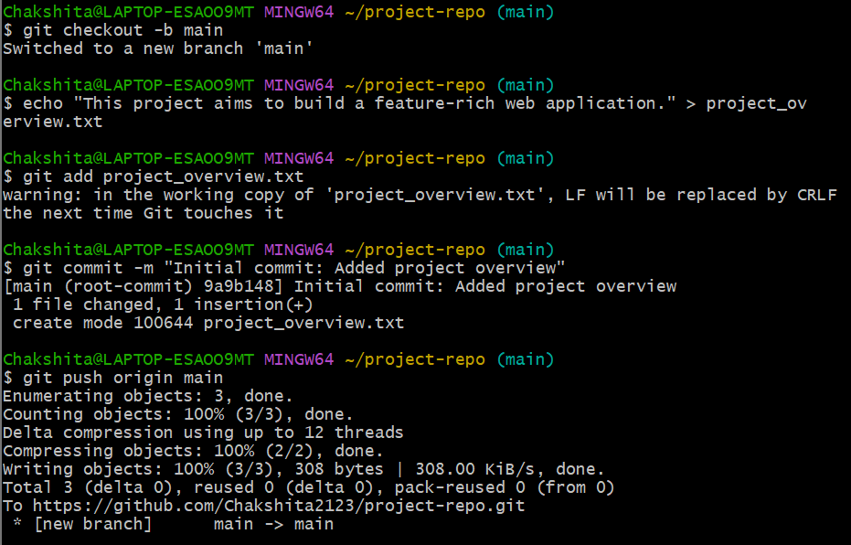

1. **Branch Creation and Updates**

Steps:

1. Create a new branch named feature-update



1. Add feature_details.txt file

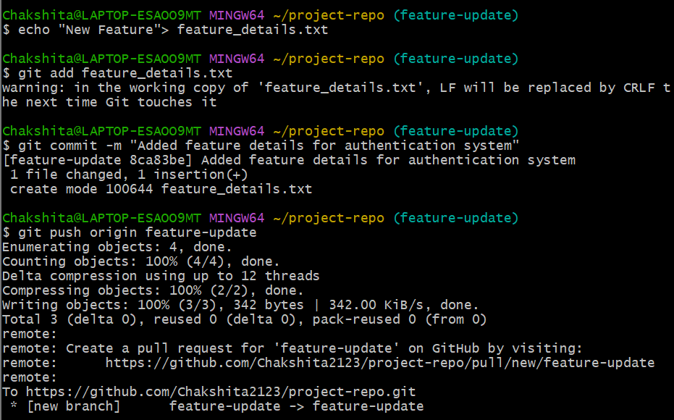

**3. Merge and Conflict Resolution**

Steps:

1. Modify feature_details.txt in the main branch  
   Switch to main and make conflicting changes:

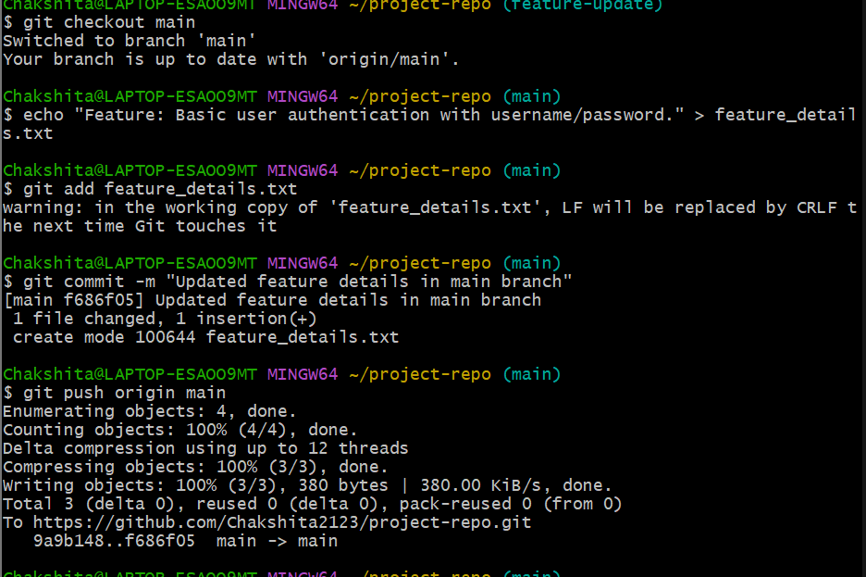

1. Merge feature-update into main

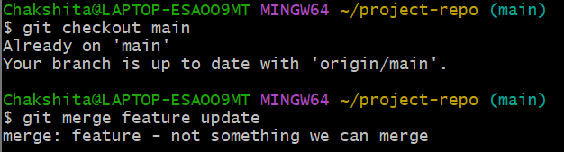

A merge conflict will occur because feature_details.txt has different changes in both branches.

1. Resolve the conflict  
   Open feature_details.txt in a text editor, manually combine both changes, then save:

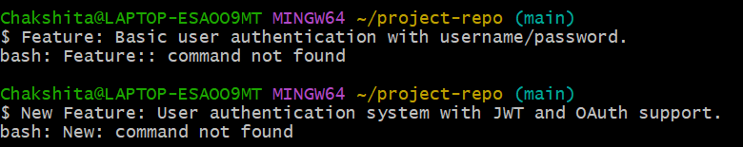

1. Stage, commit, and push the resolved changes

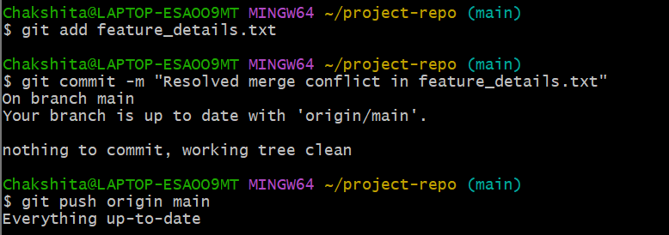

1. **Repository Audit**

Check Repository Status and History

1. Check current status
2. View commit history
3. View branch details

